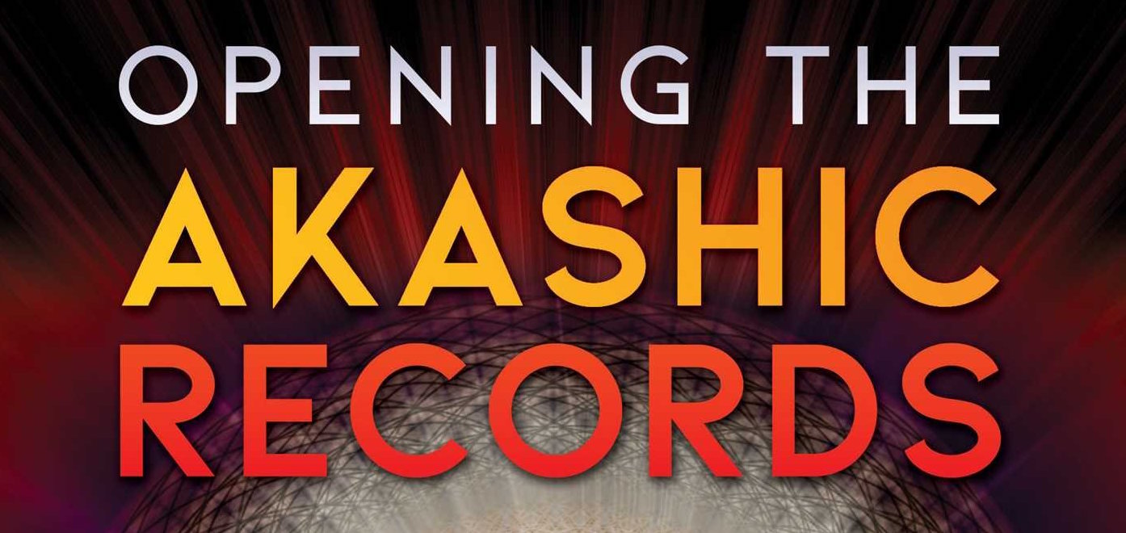

Guest for Your Show

OPENING THE AKASHIC RECORDS:
MEET YOUR RECORD KEEPERS AND DISCOVER YOUR SOUL’S PURPOSE
By Maureen J. St. Germain

Discover the Keys to Accessing the Addictive, Loving Wisdom
of the Akashic Records, or Book of Life

Open Up Your Multidimensional Awareness to Actively Engage
the Skills of Ascension and Vibrational Elevation

Dear Host,

Have you ever realized that you knew something before it actually happened? Or perhaps you were astonished that you benefitted in some way after following your intuition? For example, arriving to an appointment on time you were convinced you were going to be late for, all because you followed guidance to take a different route? Wouldn’t you like to know what people are really thinking?
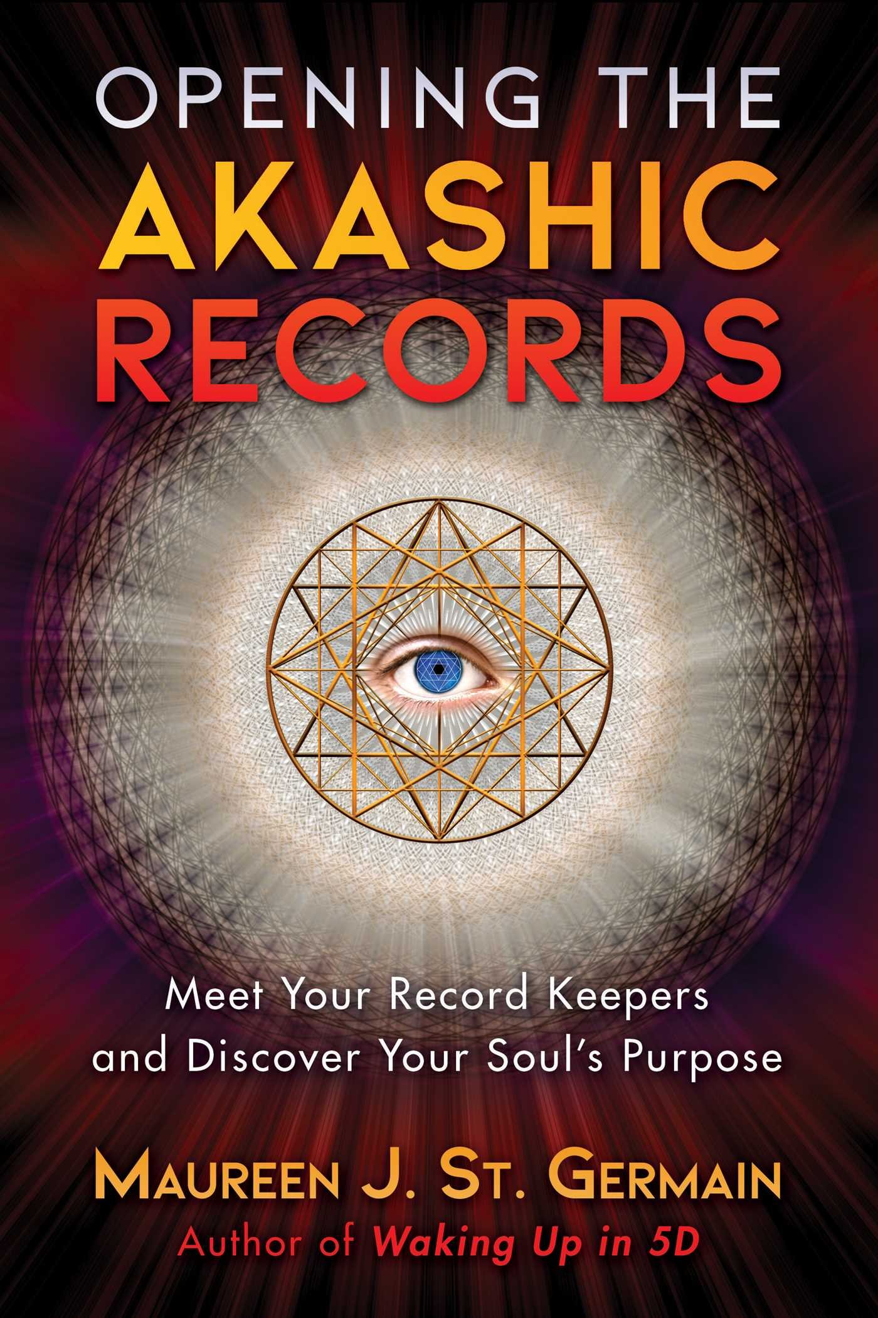
If so, according to Maureen J. St. Germain, you might have been flirting with being in the Akashic Records. This personal growth and spiritual luminary has written a book that will give you the tools to access the Library of All That Is! From the author of Waking Up in 5D, Opening the Akashic Records is THE manual for your wisdom channel, aka the Answer Key to Life.

Have you ever taken an “open book test”? – where you get to bring the course book to the exam? Join those who are using the “Open Book of Life,” and finally know why things are the way they are, discover easy solutions to any situation, and gather understanding and insight for every choice you make! Join thousands of others who have learned to open their own Akashic Records.

Whether we are aware of it or not, humanity has been given access to the wisdom of the “Keepers of Divine Wisdom,” the Akashic Records. Learning how to intentionally and permanently access the Akashic Records allows you to know the most evolved way to handle any relationship and circumstance. It allows you to see and act with greater wisdom in the world. No more competitive striving, no more struggle, no more linear one-way thinking, no more retaining pain and regret over past hurts or relationships —no more bad decisions!

Guiding you through the opportunities the Akashic Records has to offer, master teacher, Maureen J. St. Germain, reveals why you CAN have access to the wisdom of the keepers of divine understanding, how to increase your sensitivity to higher dimensional signatures, as well as how to experience multiple dimensions simultaneously. She shows how to know you are accurately transmitting the messages from the Akashic Record Keepers by identifying the differences between biased intuition and the unconditionally loving Record Keepers. She explains how to clearly identify and distinguish your connection to this higher dimension (11th Dimension) from your own ego. Opening the Akashic Records is the key to discovering the 360-degree viewpoints that expand your perception of what is possible, resulting in a deeper understanding of yourself and others.
***

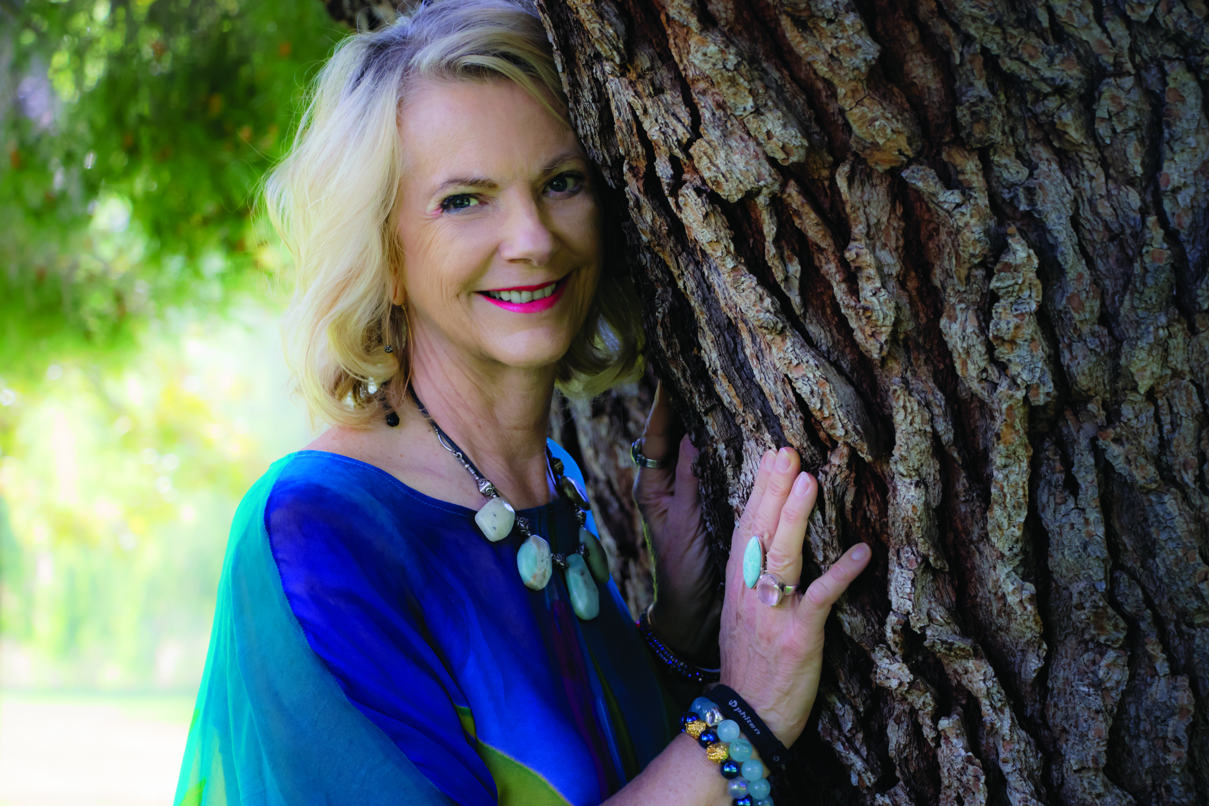
Maureen J. St. Germain is a modern-day mystic, who has become world famous for her trainings in personal development and spiritual awakening in more than two dozen countries. The author of multiple bestselling books including Waking Up in 5D she is founder of Transformational Enterprises and Akashic Records Guides International. Living in 5D herself and above (there are 12 dimensions described in the book), she has a unique first-hand perspective that she imparts to those ready to accelerate their transition into the higher consciousness and dimensions.

Maureen can illuminate:

- The ways to move beyond judgement and engage the compassion that rules the Akashic Records
- How to bend or stretch time to operate outside the rules of time as you know them
- Why opening into the Akashic Records allows you to receive and accept information in a new way
- Changing age-old reactive patterns by simply asking your Record Keepers...
- What one simple prayer allows you to access the Akashic Records
- Why the Record Keepers say there is “no more Karma”
- How to open yourself to answers that would never have occurred to the 3D version of yourself
- The Higher Self connection that can rapidly advance you permanently into 5D

Offering many of her own extraordinary experiences, along with eye-opening Akashic Records anecdotes from students and inspirational information from spirit guides, Maureen further shows how accessing your Akashic Records allows you to form a strong bond to global consciousness that will enable you to have greater impact on those in your circle and beyond. Maureen weaves much of the knowledge she has gained into your interview allowing you and your tribe fun and easy understanding of the new reality emerging through consciousness and accessing the Akashic Records.

To book Maureen St. German for a truly multidimensional interview, please send an email with the name of the show, your contact information, a proposed date and time, and the calling details.

Maureen St. Germain
212-304-2123 Land
608-345-0657 cell
Public number: 929-265-7346
Praise for Opening the Akashic Records

“Opening the Akashic Records provides a thorough and easy to understand education for those who wish to access the Akashic Records. In the past, understanding what the Akashic Records are and how to access them has been a very complex subject. In this book, Maureen makes this knowledge available to anyone.”

Lynn V. Andrews, New York Times bestselling author of the Medicine Woman series

“Opening the Akashic Records should be required reading for anyone interested in this subject. Part of the beauty of this book is its simplicity; Maureen is a master at making a complex subject easy to understand and simple to access. She also includes timely practical wisdom, which is essential to the integrity required to use your access to the Akashic Records with appropriate respect and integrity.”

Nicki Scully, author of Alchemical Healing, Power Animal Meditations, and Planetary Healing
“Opening YOUR Akashic Records is the key to your Soul.”
C. Norman Shealy, M.D., Ph.D., founding president of American Holistic Medical Association and author of Conversations with G: A Physician’s Encounter with Heaven
“Highly spiritually developed Maureen St Germain combines a comprehensive explanation of the Akashic Records with the specific protocol for individuals to get significant information from their own Higher Selves and from their Akashic records. This book is a true gift to humanity, helping us to be more compassionate with all life, more expanding in love, health, happiness, spirituality, and having deeper understanding and knowledge of who we really are and why we are here.”

Barbara Lamb, M.S., MFT, CHT , and co-authored Crop Circles Revealed, Alien Experiences and Meet The Hybrids

“Maureen St. Germain has tapped into the exquisite library of all that is. She has found a way to teach this to everyone. Her simple techniques are easy to understand. Her explainations and marvelous tools will help you accurately identify your connection to the Akashic room. Bravo for another marvelous book that is sure to be treasured by many. I wish I had had this unique book when I was doing my Akashic training”

Sylvia Moss, author of Angels of New York, healer, photographer and Akashic record reader
“Opening the Akashic Record is very likely the clearest, most thorough and useful book ever published on this subject in English. As one who has benefited from readings by skilled practitioners, I can vouch firsthand for the value that insight into the Akashic field, with the help of an experienced guide, can provide. The Akasha can answer any question of consequence, posed with respect, and can help us solve issues of health, love, money, creativity and cleanse our cellular memory of guilt, fear and pain, lifting us into new states of clarified perception and freedom. What makes this book unique, and much needed now, is that it shows you, provided you have the discipline and will stick with the 45-day program, how you can prepare to access your own Akashic Record, and then use the richness of empowered serenity that the Akasha will deliver to explore your choice of possible futures. Good luck on this exciting journey!”
Dan Furst, astrologer, actor, and author of The Rain on the Nil
“Fabulous! Maureen St. Germain offers clear and precise instructions to guide you step by step through the process of developing a close relationship with your Higher Self, the Record Keepers and Guides, so you can personally connect with them in a direct and meaningful way. It works!”
MarBeth Dunn, energy management specialist

“Opening the Akashic Records is your opening to an entire new reality, completely real, known as The Akashic Records. Within The Akashic Records is every piece of information and energy you need to create and experience the love, peace, wisdom, truth, joy, happiness, health, prosperity, and true divine fulfillment you have been searching for. The perfect accompaniment to help you open and navigate the Akashic Records.”

Lori Ann Spagna , bestselling author, spiritual teacher, ascension guide, intuitive, animal communicator, energy healer, and visionary
“Opening the Akashic Records is a journey into consciousness for the purpose of our Soul's growth. Take the Journey, it is well worth exploring. I highly recommend this book.”
Laurie Huston, intuitive counselor, coach and teacher
“Opening the Akashic Record is a straight forward and practical road map for how to access your higher self and the Akashic Records on your own. This lovely teaching encourages your spiritual identity and offers trust worthy guidance if you follow Maureen’s suggestions and choose to develop a relationship with your higher self, your intuition, and your divine guides.”
Sharlyn Hidalgo, author of The Healing Power of Trees, Nazmy, Celtic Tree Oracle cards, and Celtic Tree Rituals

"Opening the Akashic Records will assist the individual to function in their everyday life at a higher and more evolved level. Those seeking to open their Akashic Records for themselves and others, will find Maureen St. Germain’s easy step-by-step instructions, explanations and methods, a delightful way to receive spiritual esoteric wisdom.”
Barbara Becker, hypnotherapist and author of Enclosure and Time Travels

“Maureen St. Germain is one of the pre-eminent teachers of metaphysics today. Her gifts combined with innate curiosity and passion open doors for many of us into the deeper treasures of reality. This book is succinct in providing much needed information for today’s seekers of enlightenment.”
Jean Adrienne, creator of InnerSpeak™, author, and teacher

